Guided Capstone Project Report

Wendy Phillips

1. Overview

|  |  |
| --- | --- |
| **Feature** | **Rank (high -> low value)** |
| *Adult weekend ticket price* | *52* |
| Longest run | 16 |
| Fast Quads | 18 |
| Runs | 22 |
| Vertical Drop | 28 |

An analysis was performed to determine if Big Mountain Resort tickets are priced appropriately to maximize returns. The current price of a weekend adult ticket is $81, which is the 52nd highest ticket price in its market. However, the resort has several features with a much higher rank relative to its competitors, such as length of longest run and number of fast quad chair lifts. To determine whether a higher ticket price is supported, a model was built of resort ticket prices within its market segment in relation to the type of facilities offered by each resort.

Table 1. Big Mountain Resort rankings in relation to 276 competitors

2. Analysis

*2.1 Data*

An initial data set including 330 resorts in the United States was reduced to 277 resorts for which ticket price information was available. For each resort, there were 21 features related to facilities, such as available skiing area, topography, and number and type of chair lifts.

*2.2 Methods*

Linear and random forest regression models were constructed using a subset of 183 randomly chosen resorts. Models were assessed for their ability to predict ticket prices using a test set of the 83 remaining resorts. Factors related to state statistics were explored and found to have little explanatory value and therefore were not included in the final modeling. Ticket based total seasonal revenue was calculated using 350,000 visitors per season each purchasing five tickets.

*2.3 Findings*

Ticket pricing The features with the highest positive effect on ticket prices for both modeling methods included vertical drop, number of fast quad chair lifts, total runs, and snow making acres. Based on its current facilities, the model developed suggests a ticket price of $95-96 at Big Mountain Resort would be in line with pricing by its competitors. *How to express the mean standard error and what it means for price setting?*

Revenue optimization Other options to increase net revenue were considered, including both cost saving and value adding features. There are currently 105 runs in operation. While operating expenses might be reduced by closing some runs, the model predicts a corresponding decrease in optimal ticket pricing (Figure 1).

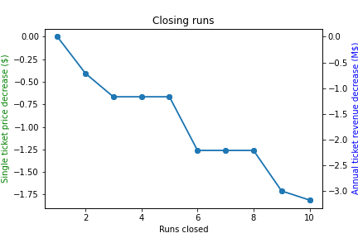

Figure 1. Decline in optimal ticket pricing in relation to number of runs closed. Left vertical access is price per ticket; right vertical access is total revenue (Million$)

As vertical drop was one of the top positive contributors to ticket price, we modeled increases in optimal ticket pricing solely through the addition of vertical drop in 50 foot increments (Figure 2). With those models it is assumed that the increased drop will be serviced either with existing chair lifts or new regular speed chair lifts, which have little effect on ticket prices. The addition of just one more fast quad chair lift had a much larger positive increase on optimal pricing (Figure 2).

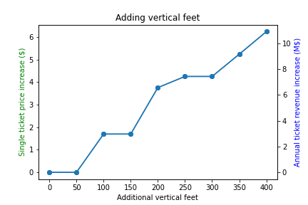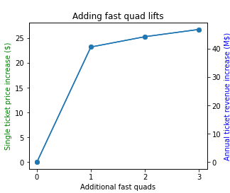

Figure 2. Left panel: Increase in optimal ticket pricing in relation to number of vertical feet added. Right panel: Increase in optimal ticket pricing in relation to number of fast quad chair lifts added. For both panels, the left vertical access is price per ticket and the right vertical access is total revenue (Million$)

3. Conclusions

Our modeling of ticket prices and facilities at ski resorts in the same market supports an increase to ticket prices at Big Mountain Resort. Additionally, the installation of a new fast quad lift could allow an increase of ticket prices of over $20. Cost savings from dismantling runs would lead to only a slight drop in ticket prices, but a cost-benefit analysis would need to be performed.